Internal testing – Certification

1. Admin view: audit creation: there is an issue when trying to create a certification issue. All the fields change after selecting Certification, and the audit reverts to Verification whenever we change something. I managed get there eventually but there is a functionality issue there.
   1. Screenshot 1 -> audit type changes after I click on the reg groups field

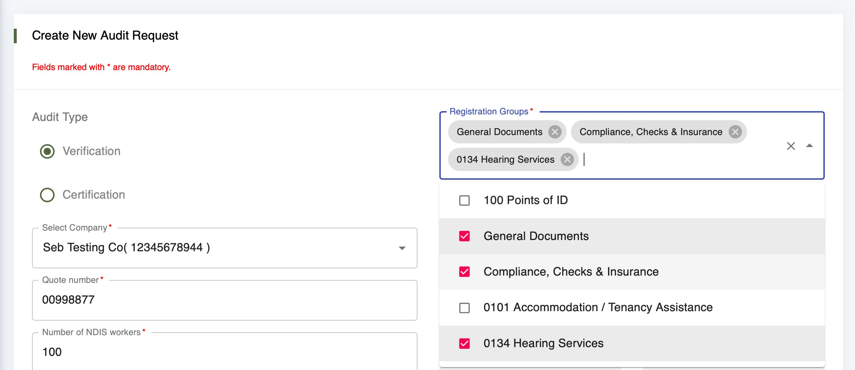

* 1. Screenshot2 -> registration groups disappear when I click back on certification

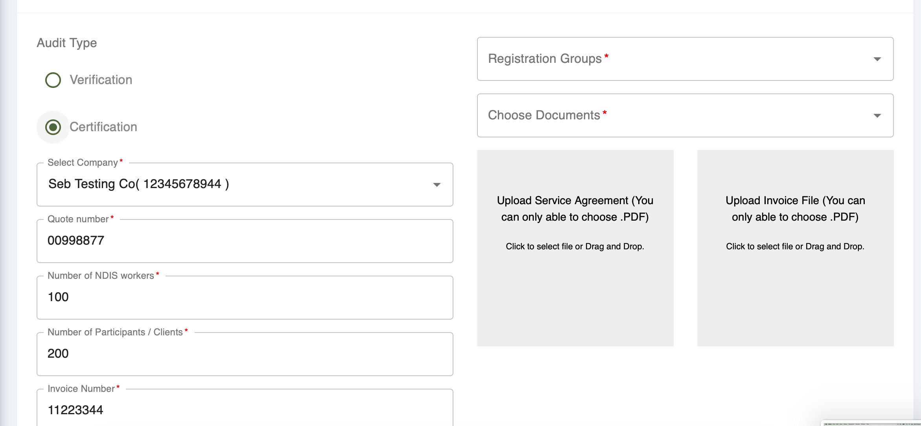

* 1. Screenshot 3 -> Then only one reg group is available

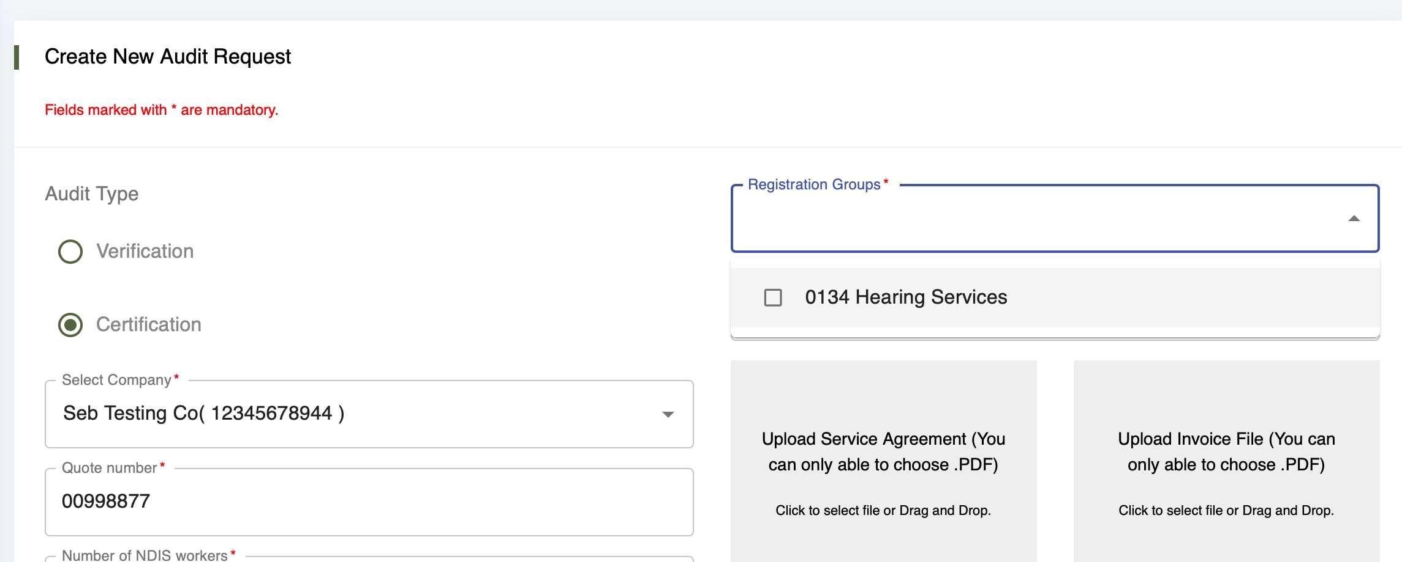

1. Client view (Both certification and verification)
   1. Transaction details should be one line, displaying “Transaction Reference”
   2. Button in dark green (“Confirm Payment” instead of “Pay” in this case)

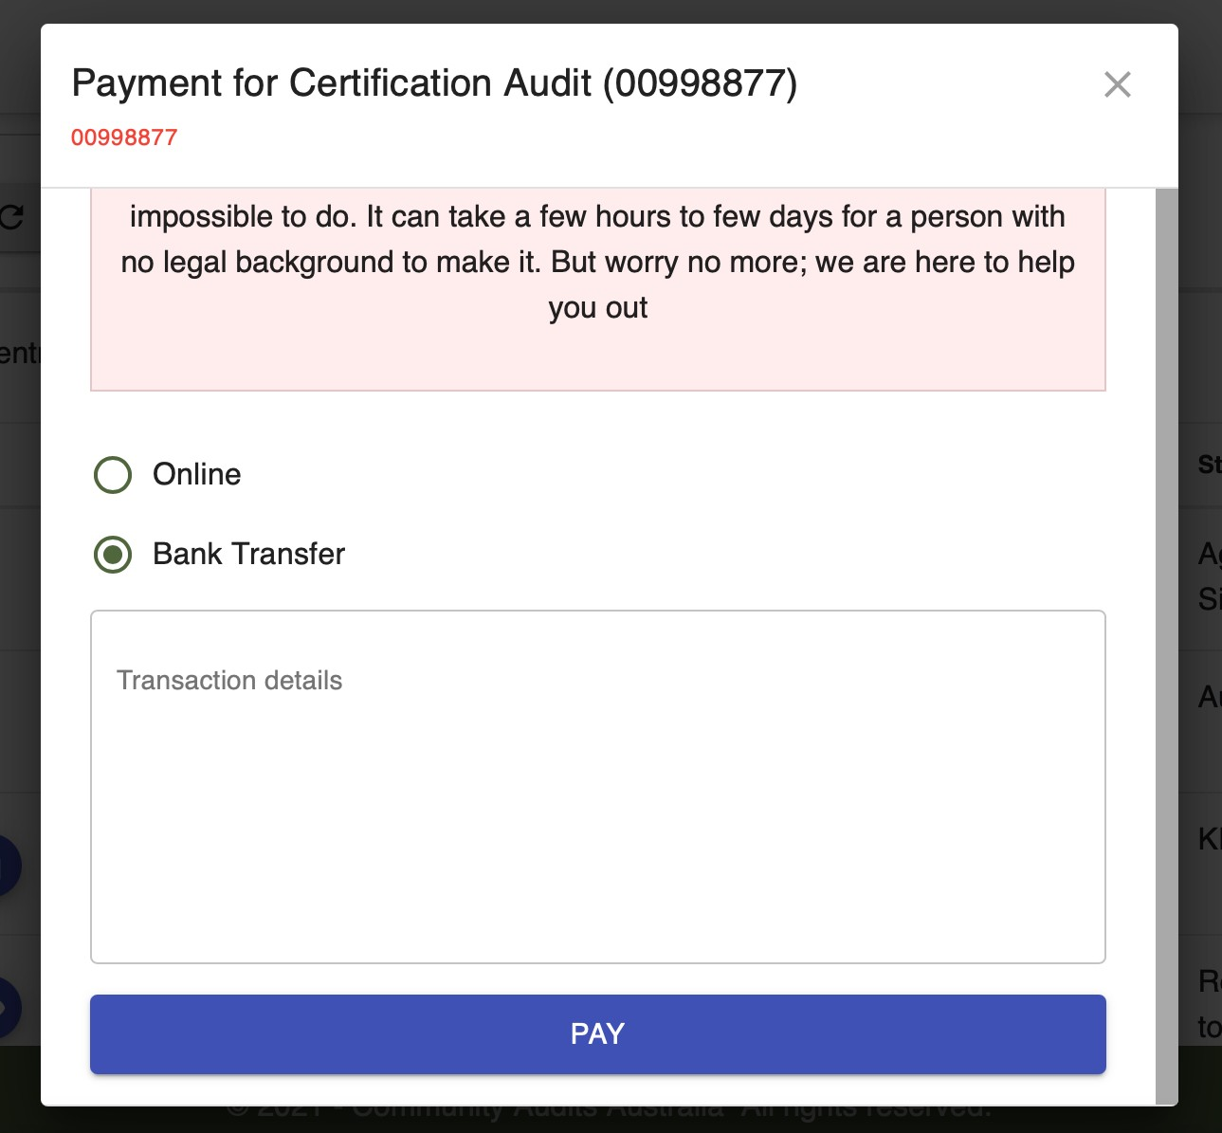

1. Client view: Documents upload:
   1. In addition to the previous comments related to the buttons of the left, buttons of the right should change as follows
      1. Change “Click to Submit all documents” to “Submit all the documents”, and change color to dark green
      2. Change color of back button to grey

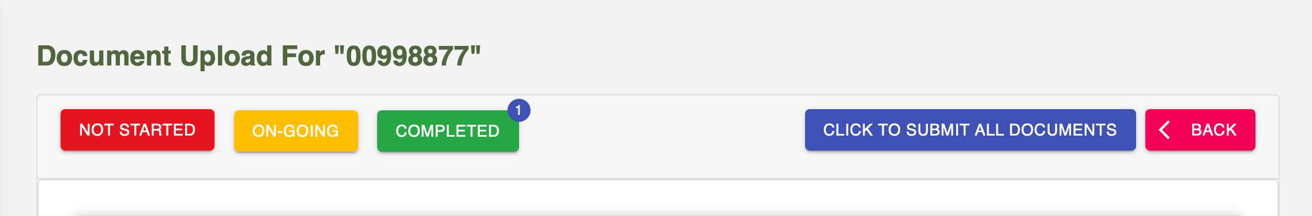

1. Client view: Audit requests
   1. Change icon description to “Request a date for Stage 2”

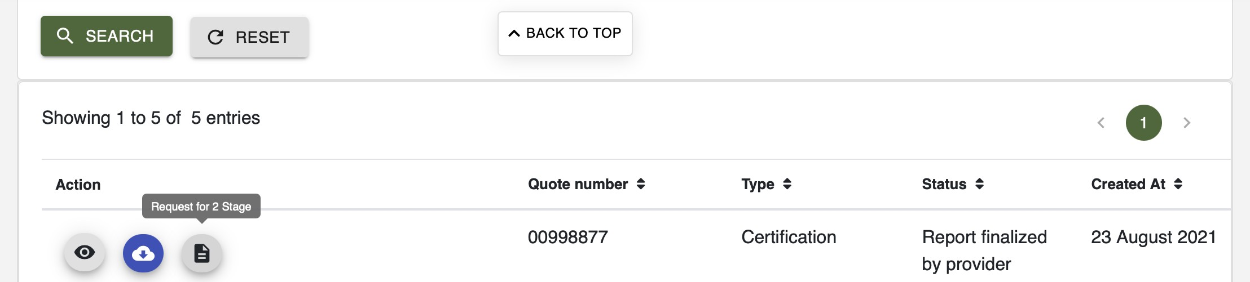

* 1. Change to “Download Stage 1 report”

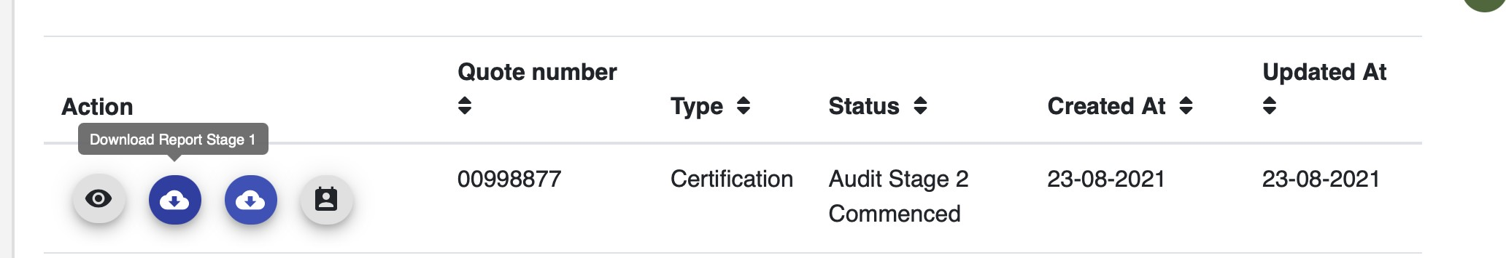

* 1. Change to “Upload Stage 2 report”

